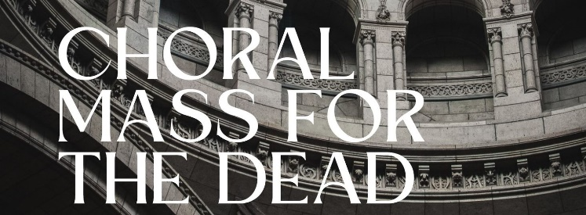
November 6 and 18, 2022
Vox Sacra
the Archdiocese of Indianapolis schola cantorum
is leading music for two Masses for the Dead

Sunday, November 6 at 2:00 p.m.
the Bishop Chartrand Memorial Chapel at Marian University
and
Friday, November 18 at 7:00 p.m.
St. Malachy in Brownsburg.

These choral Masses will be almost entirely sung, featuring the Requiem Mass by composer Maurice Duruflé. Please join us in praying for the faithful departed in the beautifully sung worship of these Masses.
FAQs:
What is a choral Mass?
A choral Mass is a Mass in which most or all of the music is sung by a choir; the choir sings on behalf of the congregation. In this case, most of the Mass will be sung by Vox Sacra and orchestra. The dialogues and several other parts of the Mass will be sung by the congregation, but less than at a “typical” Mass.

What is the Duruflé Requiem?
A Requiem Mass is any Mass for the Dead, and many composers have written musical settings of the texts of these Masses. Maurice Duruflé completed his Requiem in 1947, using the traditional chants of the Requiem Mass. It is a masterpiece of 20th Century music. Frequent Mass goers will recognize several of the melodies, at least the Sanctus and Agnus Dei, which use the familiar chants used in the Roman Missal, woven with beautiful choral and orchestral harmonies.

Is this a Latin Mass?
These Masses will be celebrated following the 2010 Roman Missal in English. While the choral parts of the Mass will largely be in Latin (with translations provided), the prayers, readings, and other responses of the Mass will be in English.

November 6th is a Sunday. Would this fulfill my Sunday obligation to attend Mass?
Yes. November 6th is the 32nd Sunday in Ordinary Time. Even though we will celebrate a Mass for the Dead rather than the Mass of the day, attending any Mass on a Sunday fulfills your obligation to attend.

